 | The Department of Chemistry  Lash Miller | SOP # C1 | COVID-1
 |  | Revision # | 01
 |  | Implementation Date | 2020-05-07
Page # | 1 of 3 | Last Reviewed/Update Date | - 2020-05-05
SOP Owner | Alan Lough | Approval

STANDARD OPERATING PROCEDURE: WORKING DURING COVID-19

1. Purpose: to provide step by step guidance how to enter and carry out experiments in the X-ray lab during COVID-19

2. Scope: applies to all qualified users of X-ray equipment

3. Prerequisites: Users must have undertaken X-ray Safety course, must be trained to use X-ray equipment and have read the ‘Guide to Recovery and Contingency’ documents provided by the Department of Chemistry.

4. Responsibilities: Users responsibility to follow SOP and be aware of all health and safety information provided by the government of Ontario https://covid-19.ontario.ca/

5.
Personal Protective Equipment (PPE): Nitrile gloves, Face mask (or non-medical covering)
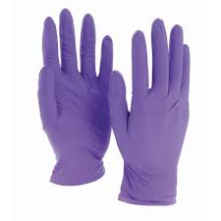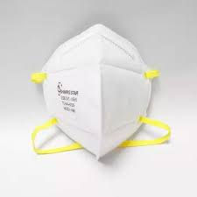

6. Entering and exiting the X-ray lab

- Ensure all proper PPE is worn correctly; correct size nitrile gloves and face covering. Gloves should be worn before entering lab. The same pair of gloves should not be used for sample preparation and then for mouse and keyboard. Used gloves should be disposed of in green bin before exiting the lab.

- Fob key entry only to west door. STRICTLY NO ENTRY via the east door and there will be no access to the Facility Managers side of the lab during COVID-19 this area will be sectioned off.

7. Running Experiments

- Only ONE person is permitted in the X-ray lab at a time therefore strict scheduling for mounting and screening crystals is enforced.

- Since there are 3 diffractometers in the X-ray lab, more than one diffractometer may be collecting data at once but in this case data collection should be monitored remotely if ONE person is already in the lab.

- Crystal mounting area should be kept clean and tidy and microscope optics should be disinfected before and after use [see: departmental disinfecting surfaces SOP]. Regular disinfecting of keyboards and mice should be carried out.

- In case of EMERGECNY see EMERGENCY RESPONSE SOP located with all other SOPs in yellow binder near sink.

8. Submitting samples for X-ray Structure determination

- There is absolutely NO ‘drop in’ sample submission.

- Please contact the facility manager alan.lough@utoronto.ca for details regarding sample submission. Samples should be contained in a zip-lock type bag along with the submission form.

- Used samples may be retrieved but only when a scheduled pick-up has been arranged with the facility manager.

- All results are in electronic form. No hard copy results

SOP-Prepared by Alan J. Lough

Reviewed & Approved by ………………………………………………………..

